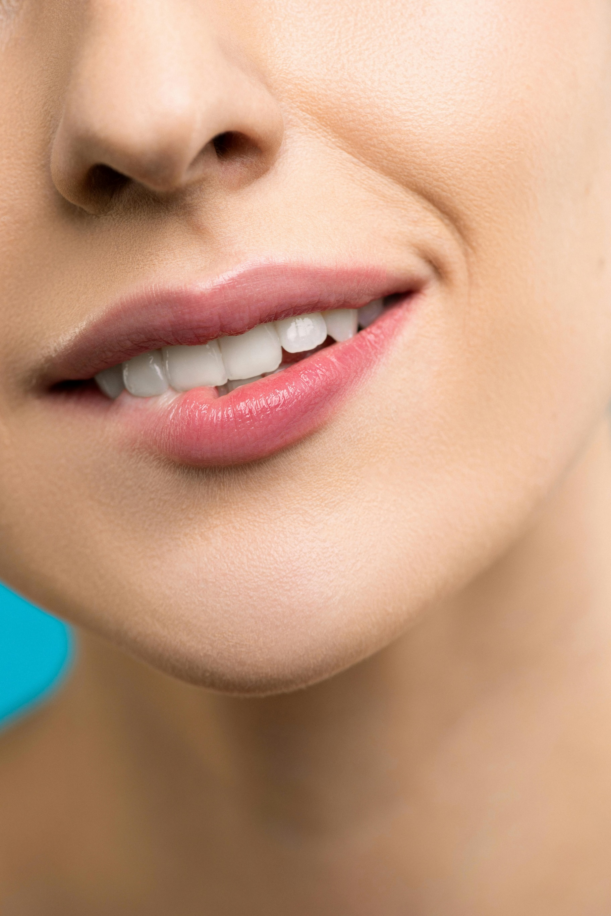

PARAFUNCTIONAL HABITS AND TMD

What are parafunctional habits?

By definition, parafunctional habits are any oral habits not associated with chewing, swallowing, or speech. These habits are usually repetitive and can contribute the development or worsening of Temporomandibular Disorders. In children, these habits can afect the development of their jaw and facial muscles and contribue to issues such as overbites, jaw shape changes, and other dental issues.

Common examples of parafunctional habits include:

* Tooth grinding (when sleeping or awake)
* Clenching (with or without altered breathing)
* Nail biting
* Thumb sucking
* Tongue thrusting
* Lip or cheek biting
* Mouth breathing
* Gum or ice chewing
* Resting hand on jaw

For anyone with jaw symptoms, a good place to start is to assess if you do any of these habits, and if so, try to reduce them. This can help calm your symptoms down and get you into better habits for your jaw.

While you are working on habits that may contribute to TMD, it is also worth doing a self- assessment to see if you chew more on one side than the other. If you do chew more on one side, try to correct this imbalance. If you are unable to change this due to pain, teeth issues, etc. It is worth getting an assessment to help treat the cause of this dysfunction.