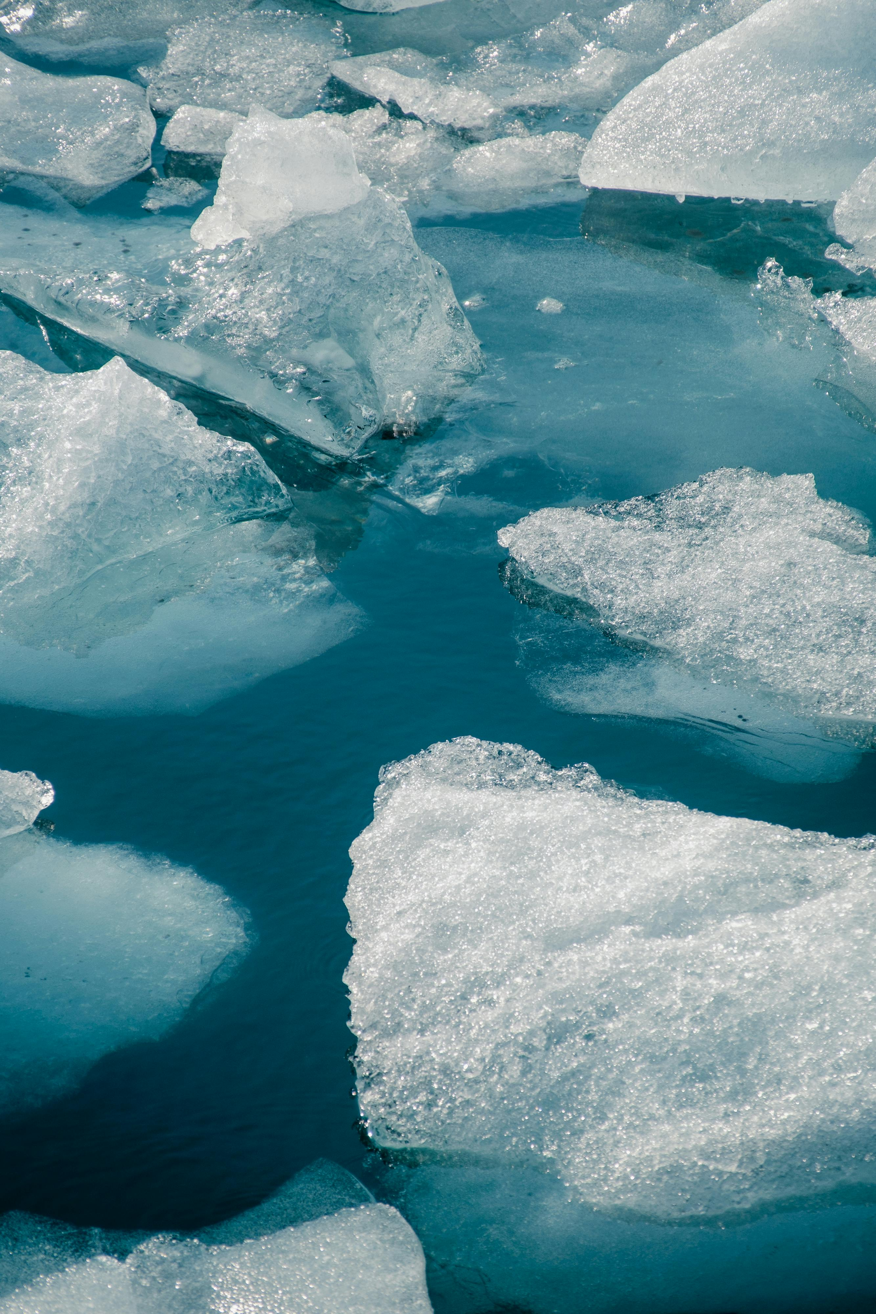

**COLD WATER IMMERSION FOR CLIMBING RECOVERY**

Cold water immersion (CWI) is a commonly used recovery method for many sports. CWI here refers to immersion of a body or body part into cold water. The use of cold air or a cold pack do not have the same evidence and are not included in this summary. CWI is thought to help reduce inflammation in muscles by reducing acidosis and causing a vasoconstrictive effect. Increased acidosis or lactic acid buildup is one of the mechanisms associated with muscular fatigue and damage, with more lactic acid leading to more muscle soreness. CWI has been shown effective at reducing acid buildup and can therefore help reduce or eliminate your muscle soreness. The vasoconstrictive effect of CWI is thought to further reduce inflammation by reducing blood flow to the area which could reduce post-exercise inflammation by limiting the influx of inflammatory markers and the efflux of creatine kinase post-exercise.

The use of CWI here is recommended as a recovery method between sessions rather than between climbs in one session. This is because the cooling effect of this treatment is not conducive to performance and accelerated reheating is not recommended following CWI as it will mute its effects. All climbers should have a proper warm up before their climb trying to reach an ideal muscle temperature of 37-40o C.

Most studies looking at CWI have looked at water 10-15o C. The duration of time in CWI in studies varied, with most between 5-15 minutes. Within those parameters, CWI appears to be an effective analgesic and can reduce muscle soreness for up to 72 hours after treatment. As far as performance is concerned, CWI is not effective at improving strength but can improve power. The mechanism by which it achieves this is not yet understood but could be useful for athletes who have competitions or trainings multiple times in a day or multiple days in a row.

If athletes are cooling multiple areas of the body, it is worthwhile considering the depth and amount of adipose tissue you have over each area. It is difficult to cool deeper areas of muscle as the more superficial layers generally continue to lose heat before allowing deeper tissues to be cooled. The amount of adipose tissue in an area will also affect how it is cooled and areas with more adipose are likely to require more time submerged.

Athletes are more likely to feel the beneficial effects of CWI compared to new or recreational climbers as they can produce more power and strength during sessions and therefore have more muscle damage. Youth athletes are likely to get less benefit from CWI as they show less muscle damage than adults’ post-exercise.

SUMMARY

* CWI can reduce muscle soreness for up to 72 hours
* CWI does not improve strength but can improve power
* The more power and strength used in a session, the more beneficial CWI will be in aiding recovery
* Youth athletes won’t get as much benefit from CWI as adults

REFERENCES

1. Hohenauer E, Taeymans J, Baeyens JP, Clarys P, Clijsen R. The Effect of Post-Exercise Cryotherapy on Recovery Characteristics: A Systematic Review and Meta-Analysis. PLoS One. 2015 Sep 28;10(9):e0139028. doi: 10.1371/journal.pone.0139028. PMID: 26413718; PMCID: PMC4586380.
2. Leeder J, Gissane C, van Someren K, Gregson W, Howatson G. Cold water immersion and recovery from strenuous exercise: a meta-analysis. Br J Sports Med. 2012 Mar;46(4):233-40. doi: 10.1136/bjsports-2011-090061. Epub 2011 Sep 22. PMID: 21947816.
3. Murray A, Cardinale M. Cold applications for recovery in adolescent athletes: a systematic review and meta analysis. Extrem Physiol Med. 2015 Oct 12;4:17. doi: 10.1186/s13728-015-0035-8. PMID: 26464795; PMCID: PMC4603811.
4. Versey NG, Halson SL, Dawson BT. Water immersion recovery for athletes: effect on exercise performance and practical recommendations. Sports Med. 2013 Nov;43(11):1101-30. doi: 10.1007/s40279-013-0063-8. PMID: 23743793.