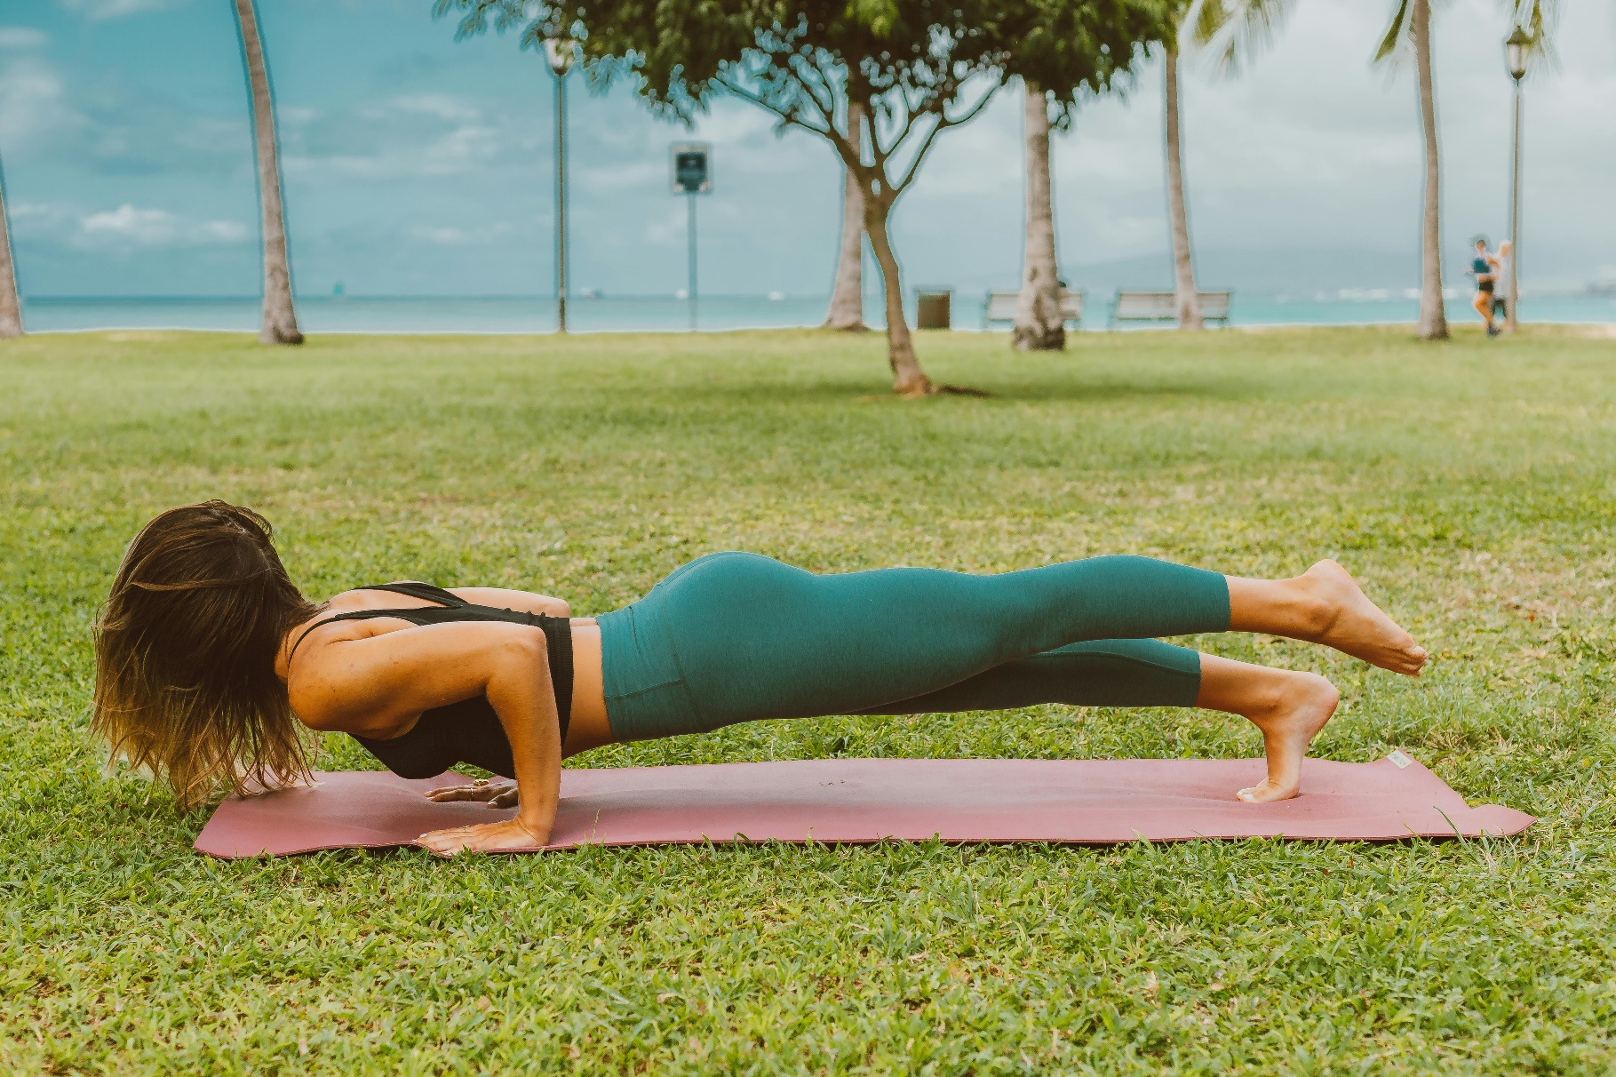
CLOSED CHAIN EXERCISE FOR UPPER BODY INJURY PREVENTION IN ROCK CLIMBERS
As some of you may have read on the previous climbing post, overuse injuries account for up to 93% of climbing injuries and are more common in the upper body, where most injuries occur. This highlights the importance of managing load and training schedules for climbers. A few previous studies have looked at strength work and cross training for climbers and found that closed chain exercises may be beneficial for climbers to prevent shoulder and elbow injuries. The idea is that this type of training will train the stabilising muscles to help support the muscles used a lot in climbing. In general, these exercises are recommended 3-4 x per week but will depend on your training schedule and fitness.
Closed chain exercises are those in which the end of the limb (foot/hand) is in contact with the ground while the rest of the body moves. This is the predominant form of movement for climbers on the wall and is a very functional and effective way to train off the wall as well.
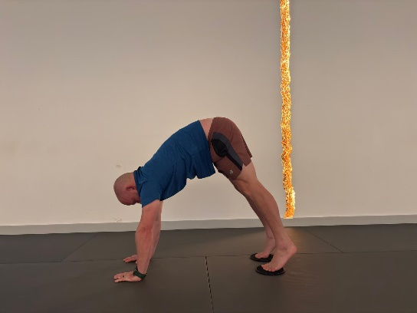
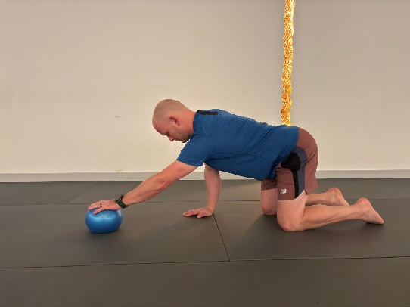
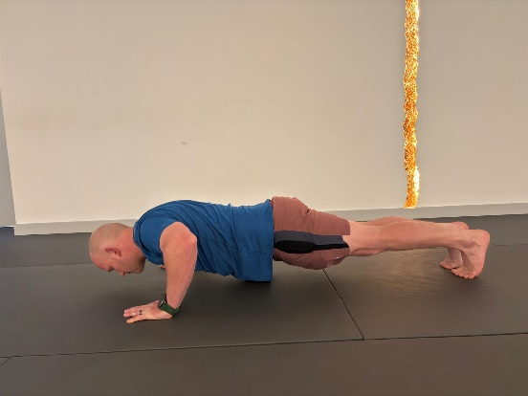
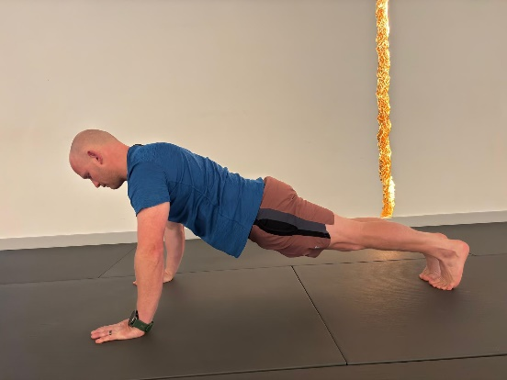
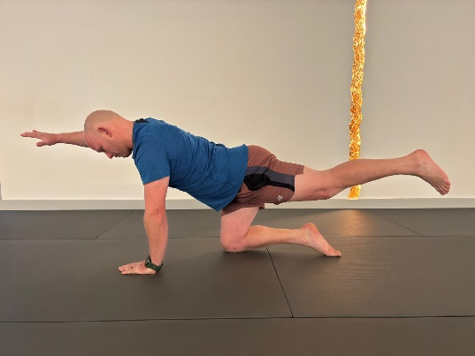
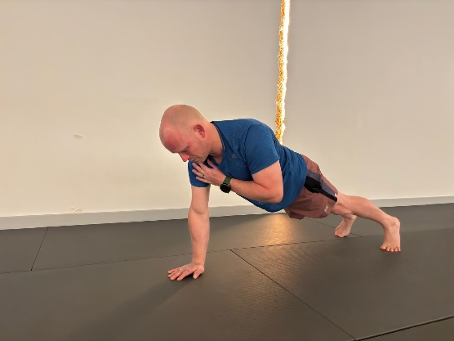
Below are some recommended closed chain exercises for rock climbers to do to reduce their risk of upper limb injury throughout their training season. Some exercises only require a mat, where others are included using a small ball or sliding discs. The frequency, intensity, etc. will differ depending on the athlete and the time of year, and is therefore not included in this paper. For those wanting more advice on the parameters of these exercises, I recommend coming in for a chat and assessment to give further guidance at our clinic in Christchurch.
BIRD DOG BALL ROLLS DOWN DOG/PIKE
PLANK PRESS UPS SHOULDER TAPS

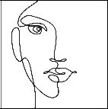

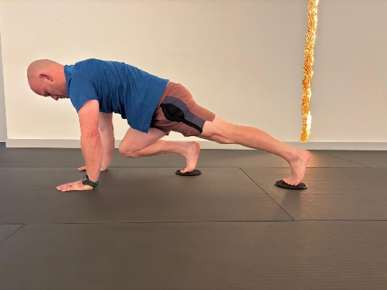
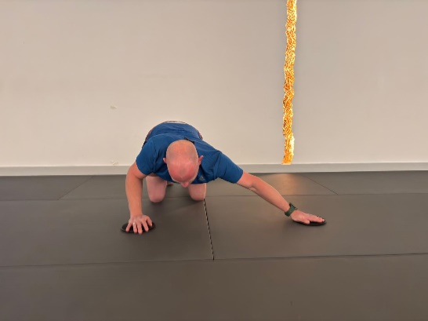
MULTIDIRECTIONAL SLIDES MOUNTAIN CLIMBERS
Exercise Descriptions and/or variations:
PLANK
Any version of plank is fine. Options of variations are knee taps, leg taps, shifting up and down through down, dog, etc. You can also add sliding discs under your feet to do slides instead of taps for these versions.
PRESS UPS
Any press up versions.
SHOULDER TAPS
These can be done in a plank as shown, on hands and knees, or in modified plank with knees down. Focus on pushing through your armpit and not letting your spine twist as you tap. Stay long through your spine and neck.
BIRD DOG
Bird dog can be done moving through the movement, performing ten second holds, or by adding movement. For adding movement, go into bird dog and then tap your hand, leg, or both, down to the floor without your spine moving. Focus on pushing through your armpits and keeping spine long.
BALL ROLLS
This can be done on all fours as shown or in plank. Focus on keeping your spine still and pushing through your armpits.
DOWN DOG/PIKE
There are many variations for this one. You can hold the down dog, transfer from plank to down dog focusing on pushing through your shoulders, or using sliding discs as in the photo to push up into a pike position.
MULTIDIRECTIONAL SLIDES
This exercise is for strengthening your shoulders in a variety of movements similar to climbing. Try slides to all directions. These can be done on the knees as shown or in a full plank position.
MOUNTAIN CLIMBERS
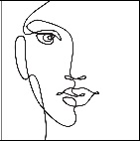
Standard mountain climbers. Can be done with or without sliders. Focus on pushing through your armpits and keeping your upper traps relaxed.

